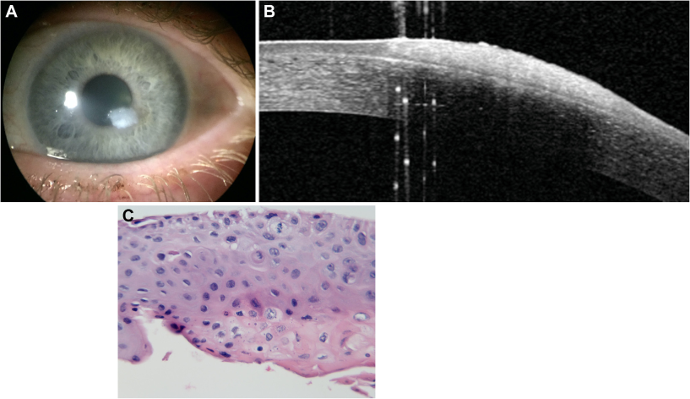

A 59-year-old woman presented with an elevated dense white corneal plaque (A). Anterior segment-OCT demonstrates confinement tothe corneal epithelium (B). Histologic evaluation demonstrated acanthosis, dyskeratosis, nuclear atypia, and mitotic figures above the baseof the epithelium indicative of moderate to severe keratinizing dysplasia of squamous epithelium. (C). Over 6 years of follow up, thecorneal epithelium has demonstrated an occasional small recurrence. Despite the suspected dysplasia, progression to aggressive ocularsurface squamous neoplasia was prevented by the patient’s innate immune system. Based on the provided images and clinical description please make an ophthalmic diagnosis for this patient. And output the diagnostic conclusions only

**Ocular Surface Squamous Neoplasia (specifically, moderate to severe keratinizing dysplasia of squamous epithelium)**